Assumption：所有的经济指标都已经全部按照当前的的通货率换算，假定未来的价格不受通货率影响，和当前等价。

问题分析：题目分为两个层次，（1）找油价历史数据信息，考虑除第一、第二题以外的重要影响油价趋势的指标；（2）根据所给指标做出函数，制定预测油价趋势的模型。针对于指标的的选择，我们结合一二两题的数据分析，以及参考文献的资料查询，确定了石油消耗、石油储备、政策、生活环境、经济（不够再加）指标；针对于指标处理，我们先通过文献资料获取了大量的有效数据，并通过数学方法，使指标与油价挂钩，通过指标与油价的关系，确立参数，建立合理的油价预测模型，最后带入实际油价数据检验油价预测趋势模型的合理性。
模型建立：
根据我们的想法，油价的趋势预测模型受多种指标因素的影响，因此我们需要对指标进行逐个分析，而油价的逐年数据是已经受各个指标影响下后的体现。因此通过对于油价的各数据量的分析，我们可以利用数学的待定系数法来寻找每个参量指标的量化度。

石油消耗与储备指标：根据文献资料，因为石油的储备与消耗的绝对差值和油价的影响直接挂钩，并且它们两者的实际值可以直观地表现出来，故我们可以直接使用石油储备与消耗的量的具体实际值来列出其对油价影响的表达式，通过文献数据计算得：
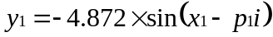
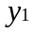表示石油储备与消耗产生的油价，表示石油储备量与石油消耗量差值的绝对值，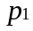表示波动性，波动程度的置信区间为95%
政策与生活环境指标：通过文献资料，我们发现该模型主要考虑人民的气候环境以及世界范围内石油主要原产地的不同规模战争爆发的情况
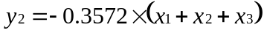
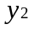表示政策与生活环境所产生的油价，，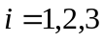，分别用于衡量气候、战争、政策，我们简化模型，三个变量统一使用离散型，01变量来代替，0表示该年不存在气候、政策、战争的因素而给给人们生活带来严重影响，反之，1表示存在；
经济指标：通过参考文献资料，用人民增长的经济水平来衡量该指标，考虑全球的经济水平，因此通过全球的每年的人均GDP来衡量，直接使用人均GDP数值和参数的关系来表示该指标对油价的影响，计算得：
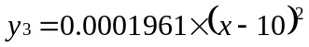
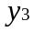表示经济因素所产生的油价，表示人均GDP
奇异点分析：
油价的奇异点象征着油价发生剧变的一个过程，也就是价位发生本质性的过渡，产生了显著的差异，根据对油价历史数据的分析，我们准确地找出油价的奇异点，也精确地对应着三次石油危机，这也充分体现了突然性时间对于油价地会产生结构性改变。因为这三次巨大的石油危机我们难以在函数中拟合出来，结合进政策与生活环境指标因素中，因此我们在此对其单独进行分析
Time | Changing mean value  ($) | Standard deviation of oil price ($ )
1981.3-1985.12 | 12.91 | 3.56
1986.3-1989.11 | 14.92 | 2.40
1991.12-2005.2 | 5.17 | 6.96
由此，我们可以利用standard price提前对历史油价数据进行处理后，再对油价函数进行拟合处理，得出较为准确的结论。

模型求解：
模型中建立的因素指标都是经济因素，所以我们将所有指标相加，推导出油价函数模型
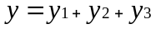
为总的油价
通过求解出的油价模型模型，带入数据，计算历年的油价，并参考比对经过通货换算后所得的油价值
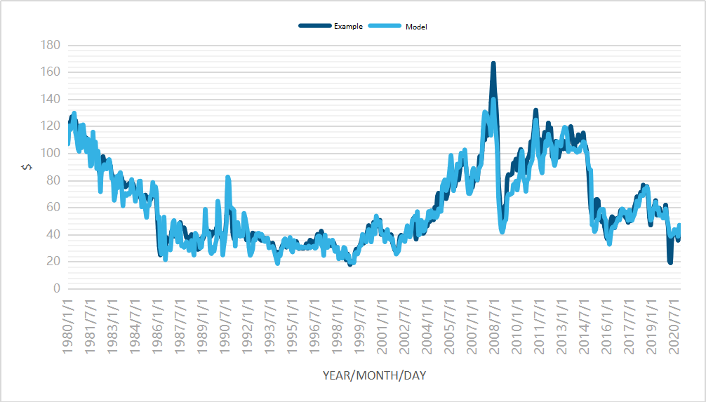
通过图像对比，我们发现通过历史数据与文献参考的量化后影响因子的参数值所得到的函数模型与过往油价基本匹配，因此我们可以推出我们的油价模型基本吻合发展趋势，可以通过该模型推导出油价的短期未来趋势
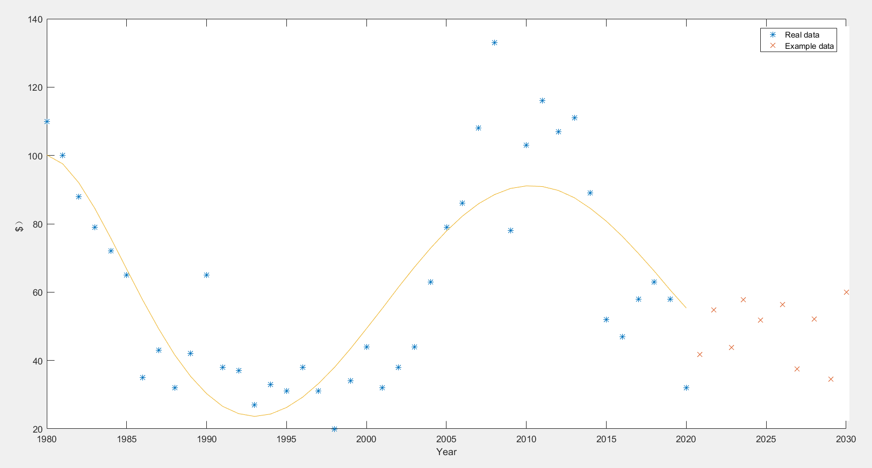
油价的长期预测
石油的资源特性决定了它价格的不稳定因素，在21世纪初，石油供不应求的局面的出现，也使得油价上升，不稳定波动更加的明显。随着多个国家石油的开采与竞争销售的格局，世界市场虽然不存在资源短缺，但是石油关系到了多个国家的财富水平。从长远来看石油会维持在较为稳定的水平，油价波动的趋势会变缓慢，波动会逐渐趋于理性水平，供需会成为主要的影响因子，理由如下
石油市场长期会处于平衡，因为经济增长速度放缓，石油的需求也在减缓，利于供求的平衡，并且更易调控，其次发展中国家需求量较大，但其对石油的价位影响却很小，因此不会出现大规模浮动
石油的高价是一把双刃剑，既不利于石油出口国也不利于石油进口国。对于石油出口国来说，进口国的需求减少，导致产能过剩，利益下降
石油市场的监管。各个国家对于石油的价位管控正在变严格，投机活动的炒作可能性急剧下降，随着制度更加完善，投机活动将会收到更大的制约，投机泡沫也将进一步萎缩
全世界正在研究开放新能源，以替代石油能源，现今，电动车的发展就是典型代表，随着科技进步，太阳能等能源也会被更具效率地开发出来以实现保护环境地同时提高经济效益。

Assumption:All economic indicators have all been converted according to the current currency rate. It is assumed that future prices are not affected by the currency rate and are equivalent to the current currency.
Problem analysis: The questions are divided into two levels. (1) Look for historical oil price data and consider important indicators other than the first and second questions that affect the oil price trend; (2) Make a function based on the given indicators to formulate forecast oil prices Trending model. For the selection of indicators, we combined the data analysis of one or two questions and the data query of reference documents to determine the indicators of oil consumption, oil reserves, policies, living environment, and economy (not enough); for indicator processing, We first obtain a large amount of effective data through literature data, and use mathematical methods to link indicators to oil prices, establish parameters through the relationship between indicators and oil prices, establish a reasonable oil price prediction model, and finally bring actual oil price data to test the oil price forecast trend The rationality of the model.

Model Construction:
According to our ideas, the oil price trend prediction model is affected by a variety of indicator factors, so we need to analyze the indicators one by one, and the year-on-year data of oil prices is a reflection of the influence of various indicators. Therefore, through the analysis of each data volume of oil price, we can use the mathematical undetermined coefficient method to find the quantification of each parameter index.

Oil consumption and reserve indicators: According to the literature, because the absolute difference between oil reserves and consumption is directly linked to the impact of oil prices, and the actual values of the two can be displayed intuitively, we can directly use the oil reserves and consumption The specific actual value of the quantity is used to list the expression of its influence on the oil price, which is calculated from the literature data:
represents the oil price generated by oil reserves and consumption, represents the absolute value of the difference between oil reserves and oil consumption, represents volatility, and the confidence interval for the degree of volatility is 95%.

Policy and living environment indicators: Through literature data, we found that the model mainly considers the climate environment of the people and the outbreak of wars of different scales in the major origins of oil worldwide
represents the oil price generated by policy and living environment, and, is used to measure climate, war, and policy respectively. We simplify the model. The three variables are uniformly discrete, and the variable 01 is used instead. 0 means that there is no climate, policy, or war in the year The factors that have a serious impact on people’s lives, on the contrary, 1 means existence;
Economic indicators: The indicator is measured by reference to the economic level of people’s growth, taking into account the global economic level, so it is measured by the global annual per capita GDP, and the relationship between the per capita GDP value and the parameter is directly used to express the indicator’s impact The influence of oil price is calculated as:
represents the oil price generated by economic factors, and represents GDP per capita

Singularity analysis:
The singularity of oil prices symbolizes a process of drastic changes in oil prices, that is, the essential transition of the price level, resulting in significant differences. Based on the analysis of historical oil price data, we accurately find the singularity of oil prices and accurately correspond to them. The three oil crises have also fully demonstrated that sudden time will have structural changes to oil prices. Because these three huge oil crises are difficult for us to fit in the function and incorporate them into policy and living environment indicators, we will analyze them separately here.
Time | Changing mean value  ($) | Standard deviation of oil price ($ )
1981.3-1985.12 | 12.91 | 3.56
1986.3-1989.11 | 14.92 | 2.40
1991.12-2005.2 | 5.17 | 6.96
Therefore, we can use the standard price to process the historical oil price data in advance, and then perform the fitting process on the oil price function to draw more accurate conclusions.

Model solving:
The factor indicators established in the model are all economic factors, so we add up all the indicators to derive the oil price function model
represent total oil price
Through the solved oil price model model, bring in data, calculate the oil price over the years, and refer to the oil value obtained after currency conversion

Through image comparison, we found that the function model obtained through historical data and the parameter value of the quantified influence factors in the literature reference basically matches the past oil prices. Therefore, we can conclude that our oil price model is basically in line with the development trend and can be derived from this model. The short-term future trend of oil prices

Long-term forecast of oil prices
The resource characteristics of oil determine its price instability factors. In the early 21st century, the emergence of oil supply in short supply has also made oil prices rise and unstable fluctuations more obvious. With the development and competitive sales of oil in many countries, although there is no shortage of resources in the world market, oil is related to the wealth of many countries. In the long run, oil will remain at a relatively stable level, the trend of oil price fluctuations will become slower, and fluctuations will gradually become more rational. Supply and demand will become the main influencing factors for the following reasons.
The oil market will be in equilibrium for a long time because the economic growth rate is slowing down, and the demand for oil is also slowing down, which is conducive to the balance of supply and demand, and is easier to control. Secondly, the demand in developing countries is large, but its impact on the price of oil is small. So there will be no large-scale fluctuations.
The high price of oil is a double-edged sword, not conducive to oil exporting countries or oil importing countries. For oil exporting countries, the reduced demand of importing countries leads to overcapacity and lower profits
Regulation of the oil market. The price control of oil in various countries is becoming stricter, and the possibility of speculation in speculative activities has dropped sharply. As the system becomes more complete, speculative activities will be more restricted, and the speculative bubble will further shrink.
The world is studying opening up new energy sources to replace petroleum energy. Today, the development of electric vehicles is a typical representative. With the advancement of science and technology, solar energy and other energy sources will also be developed more efficiently to protect the environment and increase economic benefits.

